CODE:

;========================================================
; STUDENT MARKS AND GRADING SYSTEM
; 8086 Assembly Language Project
; EMU8086 Compatible
;========================================================

.MODEL SMALL
.STACK 100H

.DATA

;================ MAIN MENU =================

MAINMENU DB 10,13,'========== STUDENT GRADING SYSTEM ==========',10,13
DB '1. Enter Marks',10,13
DB '2. Show Result',10,13
DB '3. Exit',10,13
DB 'Enter Your Choice: $'

;================ INPUT MESSAGES =================

SUB1MSG DB 10,13,'Enter Subject 1 Marks (0-99): $'
SUB2MSG DB 10,13,'Enter Subject 2 Marks (0-99): $'
SUB3MSG DB 10,13,'Enter Subject 3 Marks (0-99): $'

;================ RESULT SECTION =================

RESULTMSG DB 10,13,'========== RESULT ==========',10,13,'$'

TOTALMSG DB 'Total Marks: $'

GRADEMSG DB 10,13,'Grade: $'

;================ GRADE LABELS =================

AGRADE DB 'A$'
BGRADE DB 'B$'
CGRADE DB 'C$'
FGRADE DB 'FAIL$'

;================ OTHER MESSAGES =================

INVALIDMSG DB 10,13,'Invalid Choice! Try Again.$'

PRESSMSG DB 10,13,'Press Any Key To Continue...$'

EXITMSG DB 10,13
DB 'Thank You For Using Student Grading System!',10,13
DB 'Program Exited Successfully.$'

;================ VARIABLES =================

MARK1 DB ?
MARK2 DB ?
MARK3 DB ?

TOTAL DW ?

.CODE

MAIN PROC

MOV AX,@DATA
MOV DS,AX

;========================================================
; START PROGRAM
;========================================================

START:

; CLEAR SCREEN
MOV AX,0003H
INT 10H

; DISPLAY MENU
LEA DX,MAINMENU
MOV AH,09H
INT 21H

; TAKE USER CHOICE
MOV AH,01H
INT 21H

CMP AL,'1'
JE ENTERMARKS

CMP AL,'2'
JE SHOWRESULT

CMP AL,'3'
JE EXITPROGRAM

; INVALID OPTION
LEA DX,INVALIDMSG
MOV AH,09H
INT 21H

JMP WAITKEY

;========================================================
; ENTER MARKS SECTION
;========================================================

ENTERMARKS:

; SUBJECT 1
LEA DX,SUB1MSG
MOV AH,09H
INT 21H

CALL INPUTNUMBER
MOV MARK1,AL

; SUBJECT 2
LEA DX,SUB2MSG
MOV AH,09H
INT 21H

CALL INPUTNUMBER
MOV MARK2,AL

; SUBJECT 3
LEA DX,SUB3MSG
MOV AH,09H
INT 21H

CALL INPUTNUMBER
MOV MARK3,AL

; CALCULATE TOTAL
MOV AL,MARK1
MOV AH,0

ADD AL,MARK2
ADC AH,0

ADD AL,MARK3
ADC AH,0

MOV TOTAL,AX

JMP WAITKEY

;========================================================
; SHOW RESULT SECTION
;========================================================

SHOWRESULT:

LEA DX,RESULTMSG
MOV AH,09H
INT 21H

; DISPLAY TOTAL
LEA DX,TOTALMSG
MOV AH,09H
INT 21H

MOV AX,TOTAL
CALL DISPLAYNUMBER

; DISPLAY GRADE
LEA DX,GRADEMSG
MOV AH,09H
INT 21H

MOV AX,TOTAL

CMP AX,240
JAE GRADEA

CMP AX,180
JAE GRADEB

CMP AX,120
JAE GRADEC

JMP GRADEF

GRADEA:
LEA DX,AGRADE
JMP PRINTGRADE

GRADEB:
LEA DX,BGRADE
JMP PRINTGRADE

GRADEC:
LEA DX,CGRADE
JMP PRINTGRADE

GRADEF:
LEA DX,FGRADE

PRINTGRADE:

MOV AH,09H
INT 21H

JMP WAITKEY

;========================================================
; WAIT FOR USER KEY
;========================================================

WAITKEY:

LEA DX,PRESSMSG
MOV AH,09H
INT 21H

MOV AH,01H
INT 21H

JMP START

;========================================================
; EXIT PROGRAM
;========================================================

EXITPROGRAM:

LEA DX,EXITMSG
MOV AH,09H
INT 21H

MOV AH,4CH
INT 21H

MAIN ENDP

;========================================================
; INPUT NUMBER PROCEDURE
; ACCEPTS TWO DIGITS (00-99)
;========================================================

INPUTNUMBER PROC

; FIRST DIGIT
MOV AH,01H
INT 21H

SUB AL,'0'

MOV BL,10
MUL BL

MOV BH,AL

; SECOND DIGIT
MOV AH,01H
INT 21H

SUB AL,'0'

ADD AL,BH

RET

INPUTNUMBER ENDP

;========================================================
; DISPLAY NUMBER PROCEDURE
;========================================================

DISPLAYNUMBER PROC

MOV BX,10
MOV CX,0

DIVIDE:

MOV DX,0
DIV BX

PUSH DX

INC CX

CMP AX,0
JNE DIVIDE

PRINT:

POP DX

ADD DL,'0'

MOV AH,02H
INT 21H

LOOP PRINT

RET

DISPLAYNUMBER ENDP

END MAIN

OUTPUT:
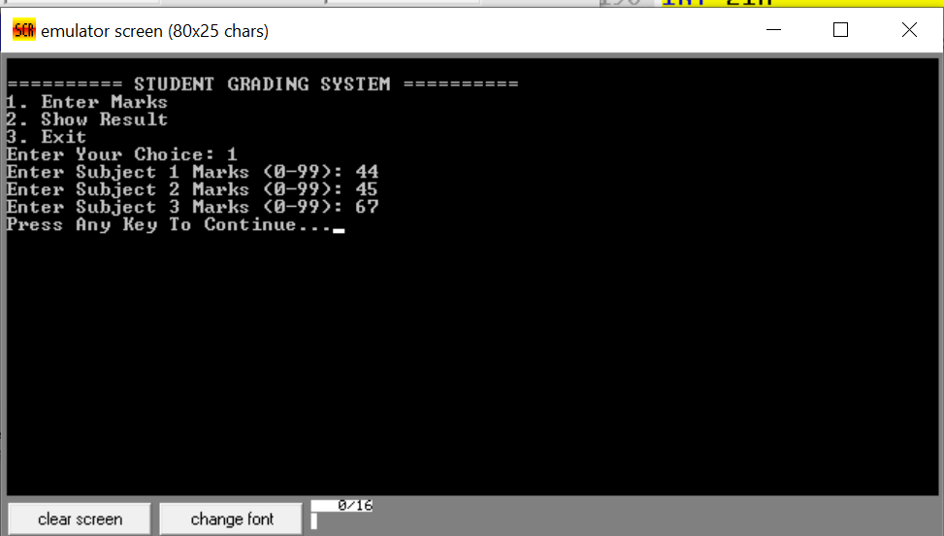

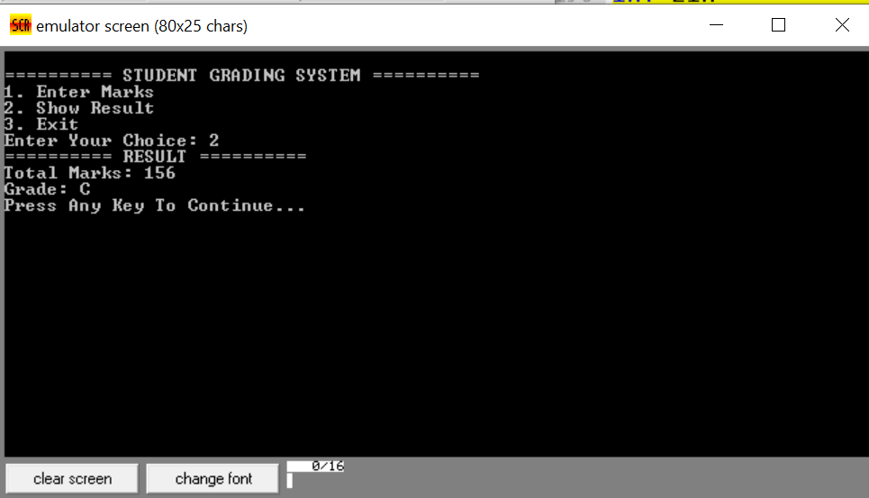

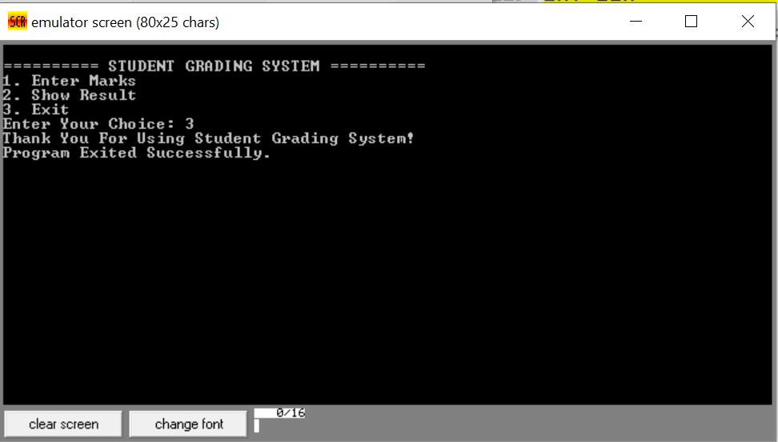

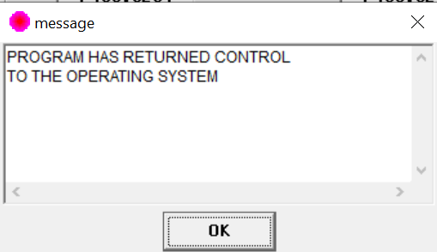

PPT CODE:
